Expected Shortfall and Value-At-Risk Scaling
Overview
Expected Shortfall (ES), also known as Conditional Value-at-Risk (CVaR), is a risk measure that quantifies the average of losses that exceed a specified Value-at-Risk (VaR) threshold, typically for a fixed confidence level. ES addresses limitations of VaR by considering the tail of the loss distribution, making it more sensitive to extreme (rare, catastrophic) events. Scaling historical VaR from the current ten days horizon to one year
1. Definition and Mathematical Formulation
Let L be the loss random variable for a portfolio over a specified time horizon. For a confidence level α (usually 95% or 99%), the VaR at level α is the smallest number l such that the probability of a loss beyond l is at most 1-α:
$$VaR_{α}(L)=inf\{l∣P(L>l)≤1-α\}$$
Expected Shortfall at level α is defined as:
$$ES_{α}(L)=E[L∣L≥VaR_{α}(L)]$$
or, equivalently for continuous distributions,
$$ES_{α}(L)=\frac{1}{1-α}\int_{α}^{1}{ }VaR_{u}(L) du$$

2. Properties and Rationale
- Coherent risk measure: ES satisfies properties such as subadditivity, monotonicity, positive homogeneity, and translational invariance.
- Tail sensitivity: ES captures information about the magnitude of losses in the tail, whereas VaR only reports the threshold.
- Regulatory relevance: ES is recommended (e.g. by Basel III) over VaR for bank capital calculations due to its robustness.

3. Computational Methods
3.1. Historical Simulation
- Collect historical portfolio PnL over the chosen horizon (10 days here).
- Sort the losses in ascending order.
- Identify the top (1- α) worst outcomes (α = 0.99 in our cases).
- ES estimate:${\overset{ˆ}{ ES}}_{α}=\text{Average of the largest} (1-α) \text{losses}$
3.2. Parametric (Analytical) Estimation
- Assume a parametric distribution (e.g. Normal, Student-t) for losses. We do this using a normal distribution for comparison purpose only.
- Calculate VaR directly from distribution quantiles.
- Compute ES using closed-form formulas, for a normal distribution there is a closed form formula: $ES_{α}=μ+\frac{σ}{1-α}ϕ(Φ^{-1}(α))$ where μ, σ are mean and standard deviation, ϕ is the probability density function, Φ⁻¹ is the quantile function.
3.3. Monte Carlo Simulation
- Generate simulated loss scenarios using relevant risk factors (e.g. asset price dynamics).
- Compute losses for each simulation.
- Apply the same procedure as in historical: take the average of worst (1- α) losses.
- This data is not provided to AIIB on a regular basis.

4. Implementation Steps
- Select 10d PnL strips for the Bank portfolio.
- Set confidence level α (to 99%, for example).
- Calculate VaR.
  - For historical/MC: identify the loss at quantile α
  - For parametric: derive quantile from distribution parameters.
- Calculate ES.
  - Take mean of all losses worse than VaR (empirical or analytical).

- Practical Considerations
  - Data quality: Sufficient and representative data are critical for robust ES estimation.
  - Extreme events: ES is especially valuable where rare but severe losses may occur (e.g. credit portfolios, derivatives).

- Application to the overall Bank portfolio and observations
      - While actual (historical) 95% VaR figures align reasonably well with a normal assumption, this is no longer at higher statistical levels.
      - Expected shortfalls completely fail to align with a normal assumption.
      - These two points shed some doubts on the usefulness/reasonableness of standard Monte Carlo simulations which, since they usually vastly rely on normal assumptions, would need plenty of fine tuning and research into ad hoc distributions.
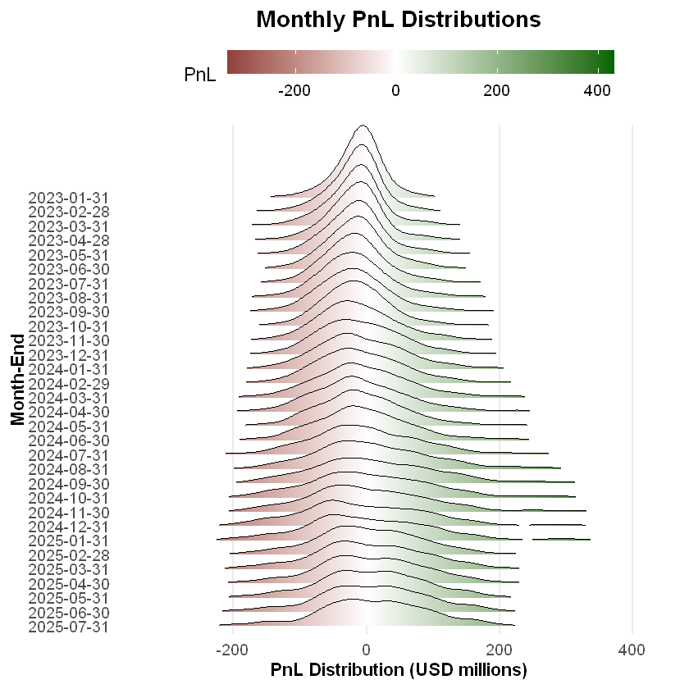
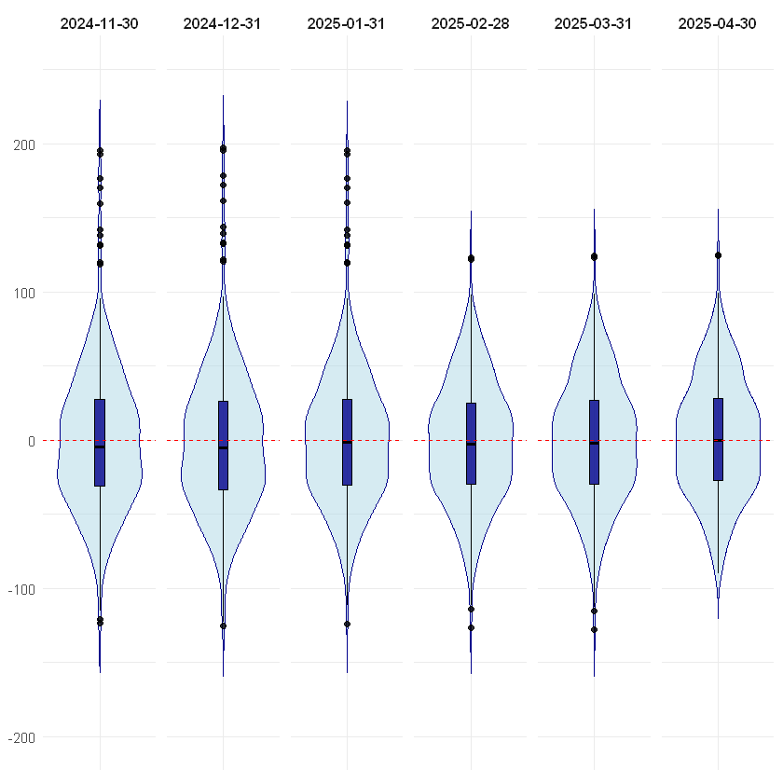
Zooming in on the months around January highlights the time when a period of very high SOFR volatility (yellow line) dropped off the time series:

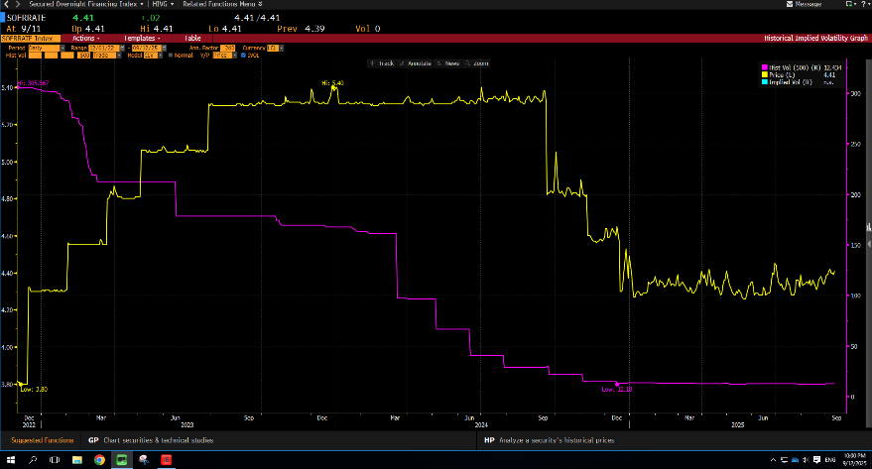

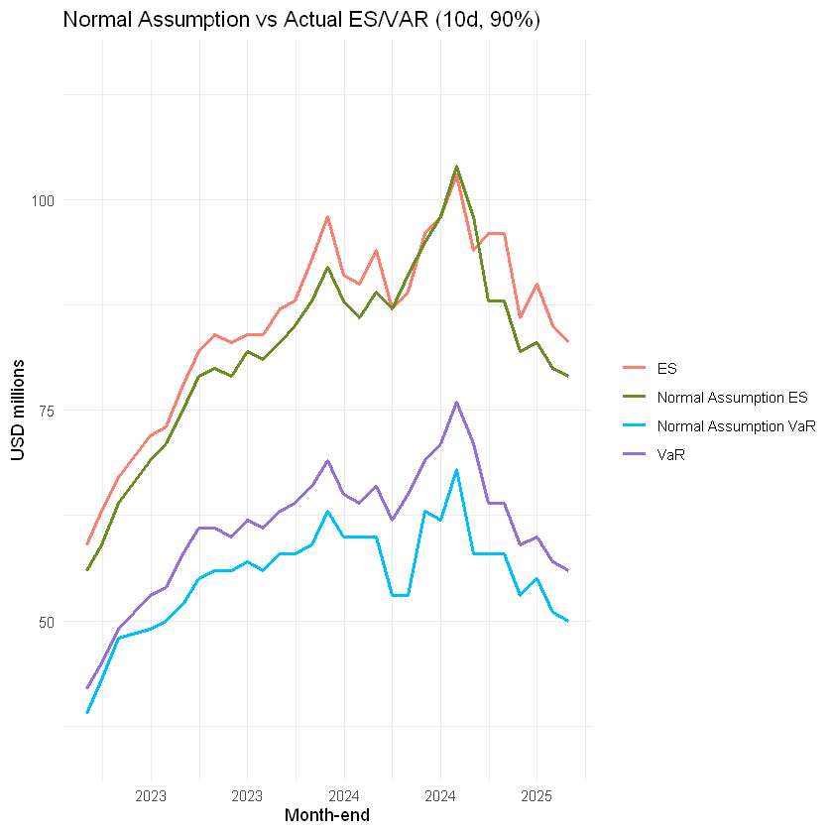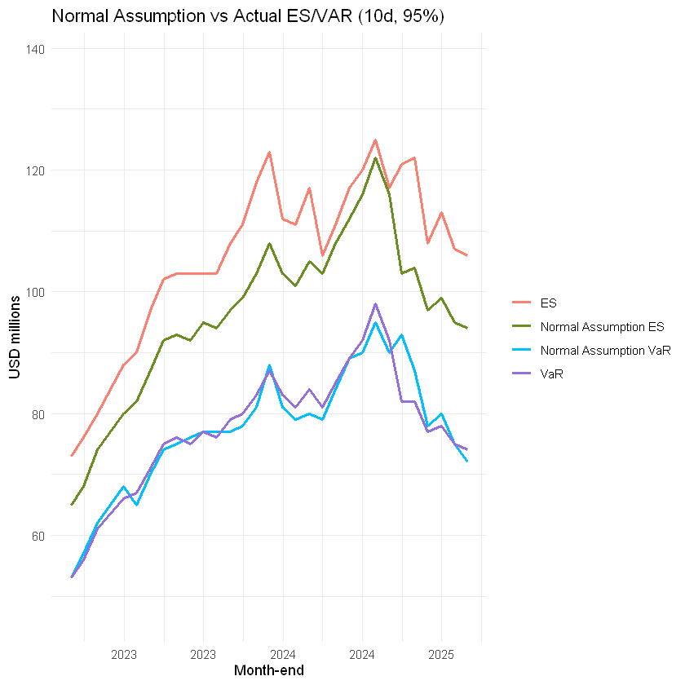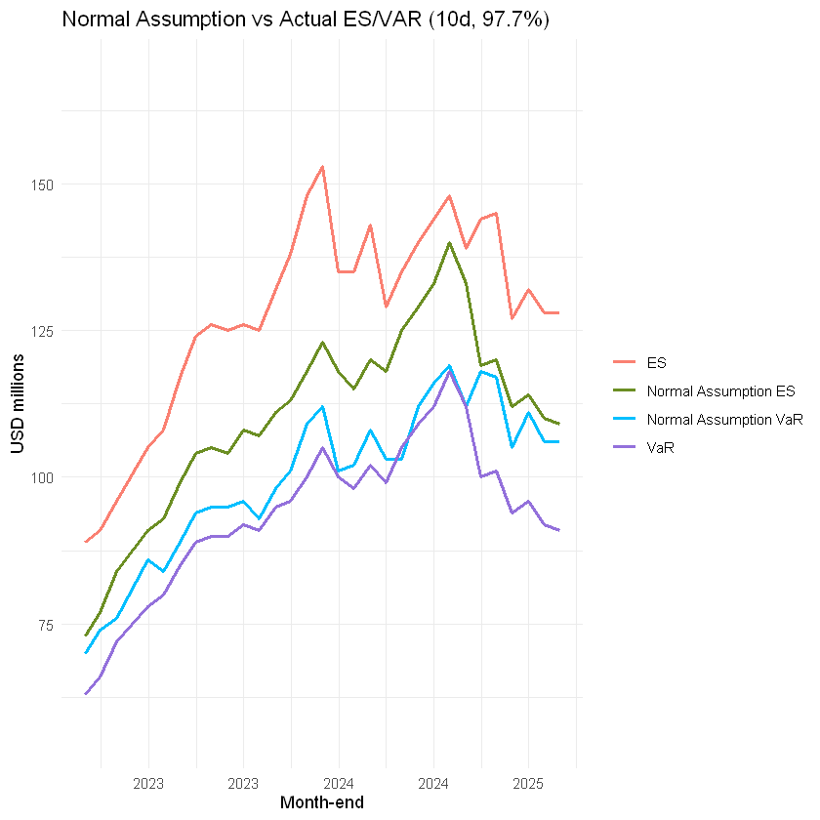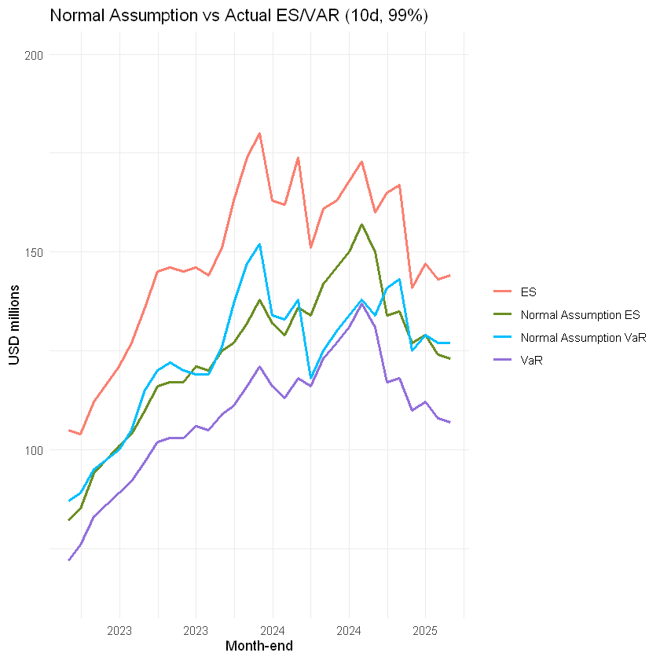

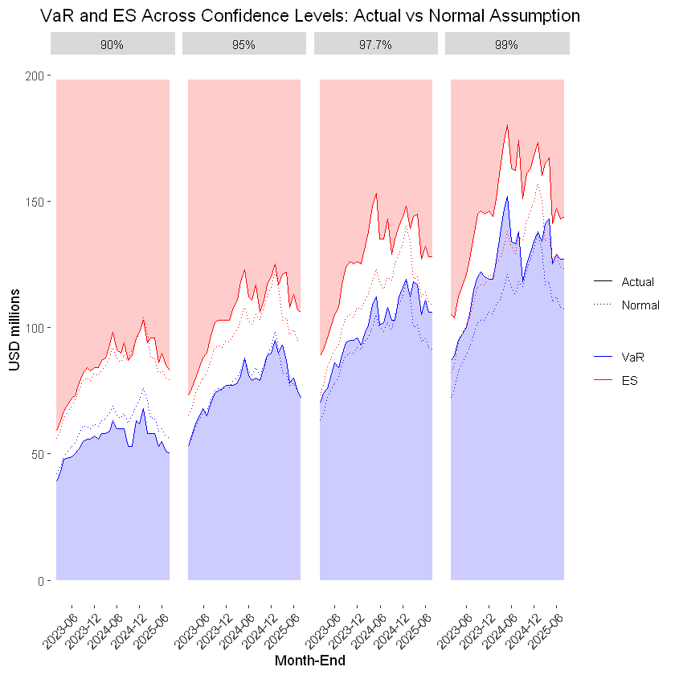

- Introducing the Cornish-Fisher expansion
The Cornish-Fisher (C.-F.) expansion is a moment-based way to approximate the value Z of a culprit distribution at a target percentile by adjusting the z values of a hypothetical Gaussian distribution with same mean/variance using actual skewness and kurtosis:
$$Z≈z+\frac{S}{6}\left(z^{2}-1\right)+\frac{K}{24}\left(z^{3}-3z\right)-\frac{K^{2}}{36}\left(2z^{3}-5z\right)$$
where:
- z is the standard normal quantile;
- S is skewness (third order moment), and K the kurtosis (fourth order moment).

VaR and C.-F. VaR match well at a 99th confidence level where skewness and kurtosis have a less impact. Expectedly, the C.-F. expansion returns much higher levels for the 99.99th percentile than the current Gaussian scaling based on the 99th percentile (which ignores the fact that the PnL distribution is not normal) when the volatility of SOFR volatility was much higher leading to more outliers. Since responsible data points dropped off the time series at the end of January this year), it follows more recent levels very well – and remains sensitive to skewness/kurtosis:
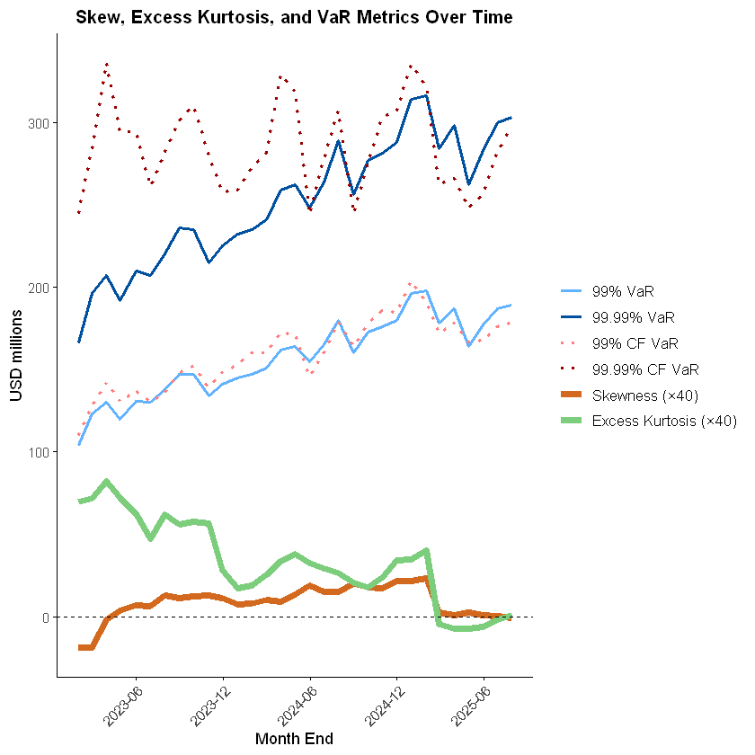
An immediate benefit these days is an expected reduction in ECap, when skewness is negligible and excess kurtosis is negative (thinner tails compared to a normal distribution with similar variance).

- Autocorrelation and time scaling
      - The current methodology assumes that ten-days rolling PnLs are independently distributed. This is obviously incorrect considering the very fact that the 10d window is precisely rolling, with nine data points overlapping from one day to the next.
      - This is confirmed by the Intaclad portfolio’s autocorrelograms generated for each day across our 500 scenarios based on non-overlapping time periods, e.g.:
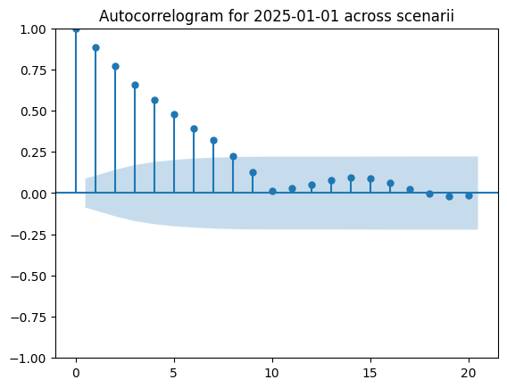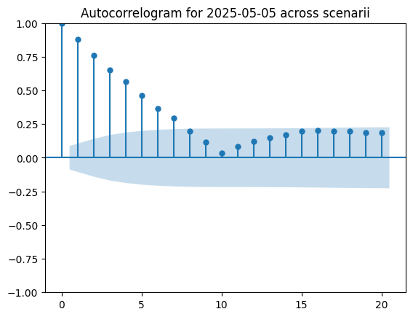
      - Based on this (see derivation in Annex 2), the literature recommends to multiply the existing factor by a function of the autocorrelation r (deemed close to 0.5 based on the 500 autocorrelograms obtained):
$$V{aR}_{T}=V{aR}_{k}\sqrt{\begin{aligned}\frac{T}{k}.\frac{1-r}{1+r} \\ \end{aligned}}$$
Where:
- T is the ultimate risk horizon (expressed in days);
- k is the “overlapping” risk horizon (days in our case).
$$\sqrt{\frac{250}{10}}becomes \sqrt{25}.\frac{1-0.5}{1+0.5} ≈1.67$$

which, if applied, yields a 67% decrease in the time horizon’s scaling factor.

Conclusion
Expected Shortfall provides a theoretically superior and practically robust measure for tail risk in portfolio loss distributions, superseding VaR in many regulatory and risk management settings. Its calculation can be approached via empirical, parametric, or simulation-based methods according to the context and data availability.
However, this latter element (data availability) makes it impractical at this stage under the perspective of 99.99% calculations considering the fact that both VaR (apart from studied 95% confidence level) and ES (apart from 90% confidence level) diverge materially from what would be expected under normal distributions. 99.99% (the ultimate target confidence level) ES/VaR is not routinely available empirically, and knowing that the distribution is not normal makes an associated closed-form formula derivation inadequate. This is further illustrated by a ridge plot of month-end PnL distributions.
Finally, VaR and ES calculated at various statistical levels exhibit similar variabilities. From a risk measurement standpoint, there is therefore at this stage little incentive to use anything but historically calculated 99% VaR. Since historical PnLs are not normally distributed there is no evidence of rationale for the current scaling factor/methodology to a 99.99% confidence level (or even to a one year horizon, however that is not the topic of the analysis).
This leads to our recommendation to refine the 99.99th confidence estimation using the Cornish-Fisher expansion. The modus operandi would be as follows:
- Calculate mean, skewness, excess kurtosis, and extract 99th percentile level using the historical PnL vectors;
- Scale up (x1.60) to obtain the 99.99th level under the hypothesis of a normal distribution paying attention to recentering;
- Apply C.-F. expansion to obtain a more realistic 99.99th level that can be used for ECap calculation purpose prior to time scaling.
Time horizon scaling can be applied separately – with, potentially, a dramatic reduction in Economic Capital figures.
Annex 1: historically calculated VaR and associated distributions (whole Bank portfolio)

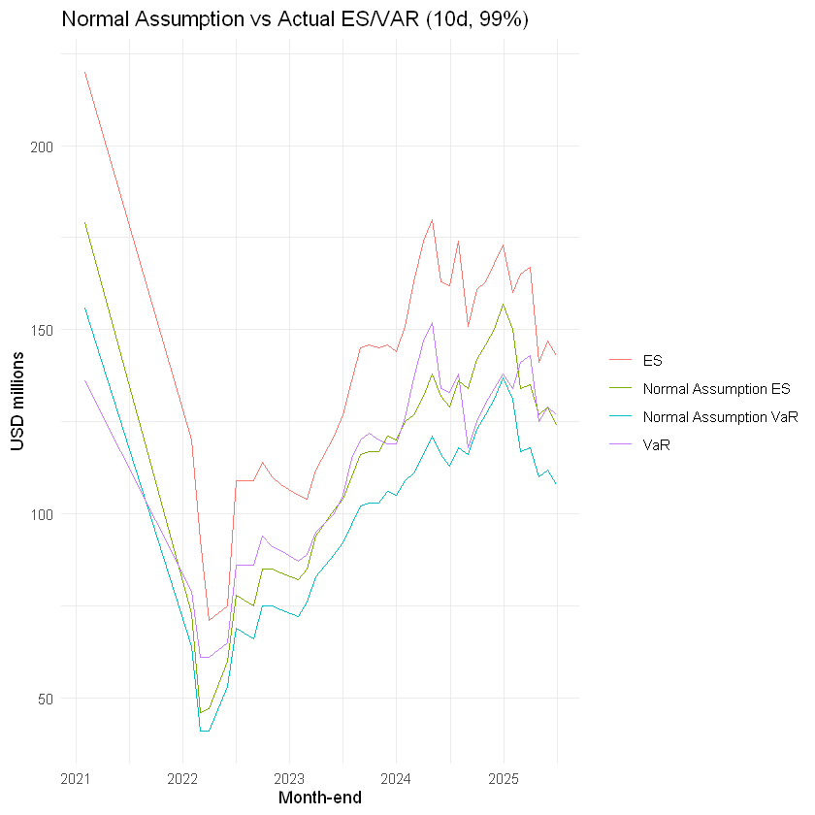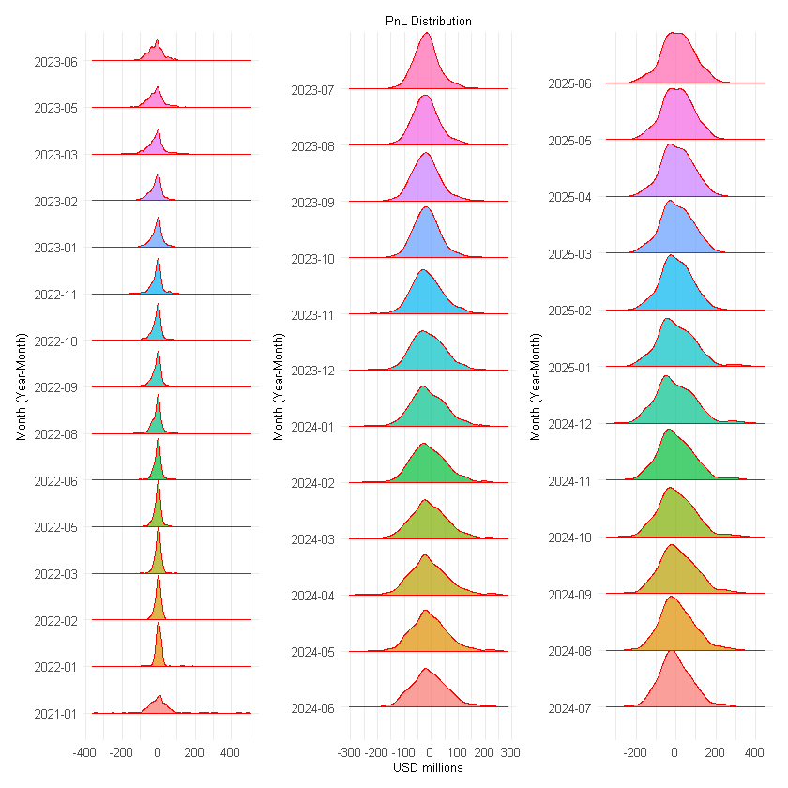

Month-End | Mean (USDm) | StdDev | 95% VaR | Normal 95% VaR | 95% ES | Normal 95% ES | 97.7% VaR | Normal 97.7% VaR | 97.7% ES | Normal 97.7% ES | 99% VaR | Normal 99% VaR | 99% ES | Normal 99% ES
7/31/2025 | 6.2 | 49 | 72 | 74 | 106 | 94 | 106 | 91 | 128 | 109 | 127 | 107 | 144 | 123
6/30/2025 | 5.5 | 49 | 75 | 75 | 107 | 95 | 106 | 92 | 128 | 110 | 127 | 108 | 143 | 124
5/31/2025 | 4.2 | 50 | 80 | 78 | 113 | 99 | 111 | 96 | 132 | 114 | 129 | 112 | 147 | 129
4/30/2025 | 3.8 | 49 | 78 | 77 | 108 | 97 | 105 | 94 | 127 | 112 | 125 | 110 | 141 | 127
3/31/2025 | 2.2 | 51 | 87 | 82 | 122 | 104 | 117 | 101 | 145 | 120 | 143 | 118 | 167 | 135
2/28/2025 | 1 | 51 | 93 | 82 | 121 | 103 | 118 | 100 | 144 | 119 | 141 | 117 | 165 | 134
1/31/2025 | 2.2 | 57 | 90 | 92 | 117 | 116 | 112 | 112 | 139 | 133 | 134 | 131 | 160 | 150
12/31/2024 | -1 | 59 | 95 | 98 | 125 | 122 | 119 | 118 | 148 | 140 | 138 | 137 | 173 | 157
11/30/2024 | 1.2 | 57 | 90 | 92 | 120 | 116 | 116 | 112 | 144 | 133 | 134 | 131 | 168 | 150
10/31/2024 | 2.1 | 55 | 89 | 89 | 117 | 112 | 112 | 109 | 140 | 129 | 130 | 127 | 163 | 146
9/30/2024 | 6.1 | 55 | 84 | 85 | 111 | 108 | 103 | 105 | 135 | 125 | 125 | 123 | 161 | 142
8/31/2024 | 4 | 52 | 79 | 81 | 106 | 103 | 103 | 99 | 129 | 118 | 118 | 116 | 151 | 134
7/31/2024 | -0.5 | 51 | 80 | 84 | 117 | 105 | 108 | 102 | 143 | 120 | 138 | 118 | 174 | 136
6/30/2024 | -2.7 | 48 | 79 | 81 | 111 | 101 | 102 | 98 | 135 | 115 | 133 | 113 | 162 | 129
5/31/2024 | -3.1 | 48 | 81 | 83 | 112 | 103 | 101 | 100 | 135 | 118 | 134 | 116 | 163 | 132
4/30/2024 | -4.7 | 50 | 88 | 87 | 123 | 108 | 112 | 105 | 153 | 123 | 152 | 121 | 180 | 138
3/31/2024 | -3.6 | 48 | 81 | 83 | 118 | 103 | 109 | 100 | 148 | 118 | 147 | 116 | 174 | 132
2/29/2024 | -4.9 | 46 | 78 | 80 | 111 | 99 | 101 | 96 | 138 | 113 | 137 | 111 | 163 | 127
1/31/2024 | -5.1 | 45 | 77 | 79 | 108 | 97 | 98 | 95 | 132 | 111 | 126 | 109 | 151 | 125
12/31/2023 | -5.6 | 43 | 77 | 76 | 103 | 94 | 93 | 91 | 125 | 107 | 119 | 105 | 144 | 120
11/30/2023 | -7.2 | 42 | 77 | 77 | 103 | 95 | 96 | 92 | 126 | 108 | 119 | 106 | 146 | 121
10/31/2023 | -8.1 | 41 | 76 | 75 | 103 | 92 | 95 | 90 | 125 | 104 | 120 | 103 | 145 | 117
9/30/2023 | -9.4 | 40 | 75 | 76 | 103 | 93 | 95 | 90 | 126 | 105 | 122 | 103 | 146 | 117
8/31/2023 | -9.5 | 40 | 74 | 75 | 102 | 92 | 94 | 89 | 124 | 104 | 120 | 102 | 145 | 116
7/31/2023 | -8.7 | 38 | 70 | 71 | 97 | 87 | 89 | 85 | 117 | 99 | 115 | 97 | 136 | 110
6/30/2023 | -8.1 | 36 | 65 | 67 | 90 | 82 | 84 | 80 | 108 | 93 | 105 | 92 | 127 | 104
5/31/2023 | -8.7 | 35 | 68 | 66 | 88 | 80 | 86 | 78 | 105 | 91 | 100 | 89 | 121 | 101
3/31/2023 | -8.5 | 32 | 62 | 61 | 80 | 74 | 76 | 72 | 96 | 84 | 95 | 83 | 112 | 94
2/28/2023 | -8.1 | 29 | 57 | 56 | 76 | 68 | 74 | 66 | 91 | 77 | 89 | 76 | 104 | 85
1/31/2023 | -5.8 | 29 | 53 | 53 | 73 | 65 | 70 | 63 | 89 | 73 | 87 | 72 | 105 | 82

Annex 2: derivation of upgraded scaling factor

